Piston Cup

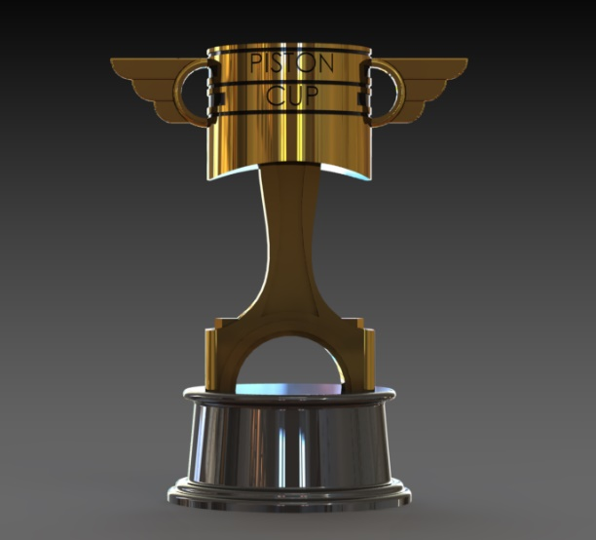

Group Name (if applicable)

Paul Lopez

Cedarcrest High School

3/11/20

1. **Introduction (2 points)**
   1. Introduction paragraph(s) gives an overview of the project. Tell what the project is in general and specific terms. **The project I decided to do this time was the Piston cup trophy from Cars. I pretty much tried my best to get all the dimensions as similar to the real thing as I could, and it turned out pretty good. I assembled the top part of the trophy to the bottom part of the trophy which was the hold for the piston. It was overall a very fun project to do and one of my best works yet.**
2. **Target Market (2 points)**
   1. Give a description of who would use the product and / or a customer list. (It could be a design for one specific user.) **This is designed for people who like to collect neat objects from movies or shows. And young audience, personally I would buy this because I grew up watching these movies and usually younger kids get whatever they want so this would be perfect for them and its also one of the best collector toys you could have from a movie.**
3. **Success in Creating Product (16 points)**
   1. Answer the question: How successful were you in creating the product?
   2. Give lessons learned (at least 2). Such as what you would do again (2). What you would not do again (2).
   3. Give specific and appropriate supporting details (12). Use as many paragraphs as needed to fully explain. (You may also embed screen shots.) **I was pretty successful in creating this product, it was nothing out of my comfort zone. I learned how to use mirror and geometry planes and I learned to try to get everything done on time because we don’t know when they might close school, so I need to use my time in a positive way. I would definitely do this project again because it was really fun, and I learned how to use a couple new things on SolidWorks. I wouldn’t spend too much time on the background setting because I was stressing over which would look better but I found the one to use. I struggled a bit on the mirror cut and where to place it specifically on the plane but I figured it out and it felt good.**
4. **Product Sketches and Ideas (8 points)**
   1. Along with the sketches, you need to talk about the ideas that led to the sketches. The sketches themselves are worth 2 points of the 8 for the section.
   2. Describe how you decided on the project (2), what requirements you decided on (2), and how you met those requirements with your design (2). **I decided to do this project because Cars is my all time favorite movie, and as a kid I always wanted the piston cup trophy so I decided to do this as my project.**
5. **Product Drawings (8 points)**
   1. You need product drawings (6 points). Along with the drawings, give some explanation of what the drawings are (2). 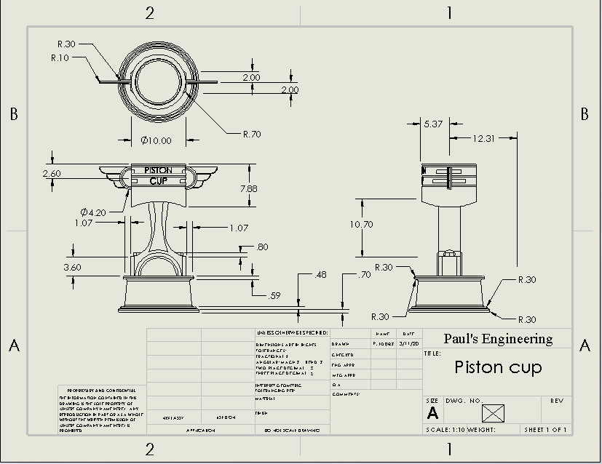  **I smart demensioned everything that was important and put the the front, top and side views down on the drawing.**
6. **Product Renderings and/or Physical Models (4 points)**
   1. Put together enough renderings to show off your product. (3) These renderings (and /or pictures of physical models) must show case the product in the best light for customers or potential customers to want to obtain the product. Also give a short explanation of how you would go about appealing to customers (1). 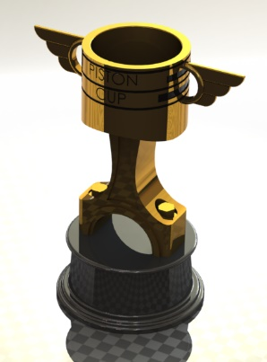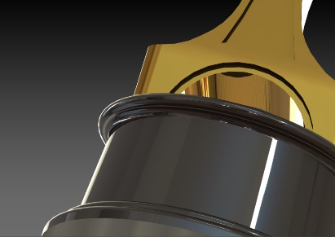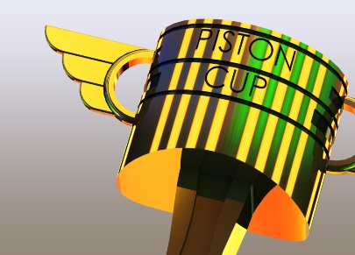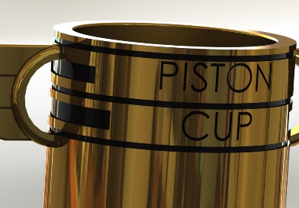  **I would box them up and label them as limited edition collectors toy and start off at a reasonable price and advertise towards the younger audience more so I would make it shiny and big.**

**Appendix/Notes**

You can put other notes or thoughts into the Appendix/Notes section. These are thoughts or notes that do not fit into the other categories but add to the understanding of the product. The Appendix/Notes section may be deleted if not used.

By the way, edit the header (put the title of your project) and footer (replace “Name” with your name so that it appears on each page).